

**INDUSTRIAL INTERNSHIP REPORT**

A summer internship report on the analysis of the different company is and its performance

**THE DEGREE OF**

**The Bachelor of Science**

**Submitted By:**

SONI SINGH

22SC02090

B.Sc. BIOTECHNOLOGY

**Submitted to:**

Dr Devjani Chakraborty

GSFC University, Vadodara

Internship Institution: GSFC University

Internship Period: **8th May 2023 to 19th May 2023**

Date of Report Submission: **29th May 2023**

**DECLARATION**

I thus certify that the Inhouse Internship Report titled "A summer internship report on the analysis of different company's and its performance" is an accurate representation of the work I did for the Internship during the relevant time from 8th may to 19th may for the award of degree (BSC), GSFC University, Vadodara, under the guidance of (Dr.Devjani Chakraborty).

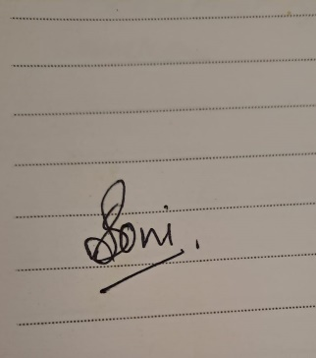

SONI SINGH

22SC02090

DATE:29th MAY 2023

**TABLE OF CONTENT**

|  |  |  |
| --- | --- | --- |
| **Sr. No.** | **Title** | **Page. No** |
| **1** | **Acknowledgment** | **4** |
| **1.1** | **Summary** | **5** |
| **1.2** | **Introduction** | **6** |
| **1.3** | **About GSFCU** | **17** |
| **1.4** | **Pharmaceutical industry** | **20** |
| **1.5** | **Sun pharma** | **21** |
| **2** | **Svaapta-IT-ALLY** | **22** |
| **2.1** | **3D Modelling** | **23** |
| **2.2** | **Mastercard** | **25** |
| **2.3** | **PBR** | **26** |
| **2.4** | **Corporate and Finances** | **28** |
| **2.5** | **Pharma company** | **29** |
| **3** | **Rolls Royce** | **30** |
| **3.1** | **Linde** | **31** |
| **3.2** | **Aarti industrial limited** | **37** |
| **3.3** | **Tata motors** | **42** |
| **3.4** | **Piramal** | **45** |
| **4** | **Gacl** | **51** |

**ACKNOWLEDGMENT**

This report has been prepared for the internship that has been done in the Fertilizer Nagar Auditorium, GSFC University to study the practical aspect of the course and implementation of the theory in the real field with the purpose of fulfilling the requirements of the course of BSc Biotechnology.

The aim of this internship is to be familiar to the practical aspect and theoretical knowledge and clarifying the career goals, so I have successfully completed the internship and compiled this report as the summary and the conclusion that have drawn from the internship.

I would like to express my sincere gratitude to our internship coordinator who have given their valuable time and given me chance to learn something despite having their busy schedule. I am also thankful to Dr DEVJANI CHAKRABORTY (Program Coordinator of BSc Biotechnology) and other staff members for their co-operative support and presenting with an opportunity for me to have a practical experience in this organization.

Lastly, I would like to thank Mr AKASH BHAVSAR for guiding us till the end of the internship. I am also grateful for providing several documents, papers and data as well as sharing their experience with me and teaching me different idea to sustain in the industries. This internship was very helpful, audacious, and supportive to my career through which I gained valuable information that will definitely makes a favourable impression on me as a prospective worker.

Sincerely,

SONI SINGH (22sc02090)

**SUMMARY**

As this internship was primarily focused on finance, which was beneficial to many BBA students, there were certain portions where I learned about the many technologies needed to create a product in the industries. What is required to build a product? There are numerous multidisciplinary areas that are interconnected to make a product. I also learned which departments are accountable for producing the greatest products.

During the internship, for example, they explained the roles of HR, finance, and the healthcare department in the industry. As a science student, we must take care of these departments in addition to producing a product to maximise the product's efficacy. They also gave us a glimpse of the most important thing before going to any industry that one should present themselves in front of the industrialists.

**INRODUCTION:**

GSFC University is being modelled as a boutique University to produce 100% industry ready manpower with 80% students getting employment. It is housed in lush green surroundings of Fertilizer Nagar. The teaching at GSFC University is inspired by medical education principles. In case of a Medical College, a hospital is attached to it, where students learn to apply theoretical knowledge to practical aspects of medical treatment. Here our university is housed at handshaking distance from GSFC’s 22 plants.

A four-pillar approach is adopted so that theoretical knowledge application in day-to-day working of the organizations / industries is practiced. First pillar is e-enabled virtual labs, where students grapple with various aspects of virtual instruments and carry out experiments number of times and understand ‘why’ of theory. Second pillar is physical labs where students perform same experiments in physical world with real fluids and lab model equipment. Third pillar is their exposure to real plant and machineries to full scale sizes, where full understanding of theories taught in classrooms as applied to industry is experienced by students at superficial level. Fourth pillar is 4 weeks internship after every semester where he is expected to deep dive and understands the plant and machinery, processes etc.

GSFC University has made it compulsory for its undergraduate students to undergo practical work in the form of a four- week industrial internship at the end of each semester known as Student Industrial Internship (SII) Carries 2 credits in each semester. SII provides opportunity to the students to experience the actual working domain of the industry. The students will develop skills in work ethics, communication, management, leadership as well as working in a team.

GSFC University shares a close collaboration with the local Industries for this internship programme, which is the key element of the University Industry collaboration.

The University offers following courses: -

Bachelor of Technology (B.Tech.) - Chemical, Mechanical, Computer Science & Engineering, Fire & Safety, Health & Environment and Civil

Bachelor of Science (B.Sc.) & Master of Science (M.Sc.) - Chemistry and Biotechnology

Ph.D. – Chemistry & Biotechnology

Bachelor of Business Administration (BBA)

**2. KEY OBJECTIVES OF INDUSTRIAL INTERNSHIP**

The Key Objectives of the Student Industrial Internship (SII) is to develop in students the skills & knowledge demanded by “world of work”:

* To expose GSFC University students to the actual working environment of industries which will enable them to relate theoretical knowledge with practical application in industries.
* To develop skills in safety practices, work ethics, communication, management, leadership quality, team player etc.
* To establish a close bond between the industries and GSFC University.
* To develop their soft skills like verbal and written communication.

**3. LEARNING OUTCOME**

At the end of this internship, students can:

* Demonstrate skills in communication, management, and teamwork.
* Adopt ethics, professionalism and HSE practices in work culture.
* Demonstrate continuous building of skills and knowledge throughout the internship.
* Appreciation of sustainability issues in industry.
* Expand philosophy and knowledge in the field.
* Gain a greater understanding of the duties and responsibilities of fitness professional.
* Identify personal strengths and weaknesses.
* Understand and adhere to professional standards in the field.
* Relate to, interact with, and learn from current professionals in the field.
* Broaden your knowledge and education by continuing to learn.
* Put theory into practice.
* Develop the initiative and motivation to be a self-starter and work independently • Update knowledge as standards are revised.

**4.DETAILS OF STUDENT INTERNSHIP PROGRAM**

As important and necessary as book knowledge is in the education and Internship of the future generation, nothing compares to actual work experience. For it is only when knowledge is applied that it becomes tangible, real and truly understood in all its usefulness and practicality.

It is in this spirit that GSFC UNIVERSITY undergraduates must undergo a compulsory internship Programme within the course of their degree studies.

With foresight and knowing the kind of graduates we wanted to produce, this internship Programme has been implemented right from semester one. Ours is a unique one month every semester (8 months total) long industrial Internship Programme, which we feel is just the right amount of time to immerse the undergraduate in the completion of real-world tasks and projects in the working environment pre-graduation. Too short a Programme would just be glossing the surface while a longer stint would be too drawn out. Through the years, we have partnered with numerous local and international companies who have gladly joined us in this internship undertaking.

|  |  |
| --- | --- |
| **School** | **Field of Studies** |
| School of Technology | Chemical, Mechanical, Computer Science Engineering,  Fire & Safety, Health & Environment & Civil  Engineering |
| School of Science | Chemistry, Biotechnology |
| School of Management | BBA |

Interns available are from the following Bachelor Degree Programme:

**1. HOST COMPANIES**

* Students are only allowed to undergo SII at companies, which have been assigned by GSFC University.
* GSFC UNIVERSITY Internship guidelines will be given to host company mentor for their reference

**2. DURATION AND PERIOD OF INTERNSHIP**

The minimum duration of the SII shall be for a period of 4 weeks.

Transport / Accommodation arrangements will be by students only. However, economically weaker students will be given some support.

**3. TRANSFER OF INTERNSHIP PLACEMENT**

Students are **not encouraged** to transfer or change to another Host Company without prior approval from GSFC UNIVERSITY and agreement from the Host Company.

**4. LEAVE**

In the event that the student has to take leave due to emergency, student shall seek prior approval from the Host Company and assigned faculty. In the case of prolonged leave (exceeding 3 days) due to hospitalization, student shall notify both GSFC UNIVERSITY and host company in writing and provides necessary documents as evidence.

In case of complaint / request from Host Company, students will be shifted immediately.

**5. INSURANCE**

Insurance will be taken by GSFC UNIVERSITY as per group accident insurance policy for Rs. 1.0 Lac.

**6. SAFETY TRAINING**

Student shall abide by safety norms as students are encouraged to attend safety training as deemed fit by the Host Company.

**7. VISITS BY THE GSFC UNIVERSITY (ACADEMIC) FACULTY**

SII assessment visit will be conducted at the Host Company once every week or time frame as discussed and finalized with mentor from Host Companies.

The faculty mentor during their visit should also be involved in following areas:

* Case study development.
* Individual students related issues.

**5. RESPONSIBILITIES:**

**1. RESPONSIBILITIES: INDUSTRY MENTORS**

Host Companies plays an important role in ensuring the success of the SII. They are expected to provide the following support:

1. Plans and schedules of the overall internship programme in consultation with faculty coordinator to ensure that it provides maximum opportunity for students to obtain useful experience related to their field of study.
2. Provides briefing on the background of the organization / company.
3. Keeps the daily student attendance record.
4. Discusses with the faculty mentor the details of the internship programme’s expected outcomes.
5. Supervises and guides students in their industrial internship.
6. Provides the necessary facilities, equipment, tools and guidance to students.
7. Provides necessary recommendations to improve the programme.
8. Assess logbook fortnightly and checks their detailed logbook reports.
9. Evaluates students’ oral presentation during assessment visit using the presentations.
10. Evaluates Students’ Performance and Competency.
11. Evaluates Industrial Internship Report and knowledge gained by questions / assignments.

**2. RESPONSIBILITIES: FACULTY MENTOR**

1. Establish and maintain communication with students and company mentor throughout the duration of the internship period.
2. Develop and maintain good rapport with the Host Companies.
3. Visit the Host Companies one to two days in week and review the industrial internship schedules with Host Company mentors.
4. Complete and collect all the assessment forms from Company mentors at the end of the assessment visit.
5. Addresses internship matters / updates at respective departments.
6. Assist in compiling students’ scores.
7. Promotes and establishes Industry relationship via internship.
8. Provide necessary recommendations to improve the programme.

**3. RESPONSIBILITIES: STUDENTS**

1. To submit various reports duly completed during the industrial internship.
2. Adhere to the industrial internship and Host Company’s rules and regulations.
3. Follow the Host Company’s safety procedures.
4. Help the industry mentors / workers in maintenance or routine jobs.
5. Maintain good discipline and personal conduct.
6. Listen to and follow their mentors’ instructions.
7. Meet work schedules on time.
8. Discuss with mentors on the Internship schedule (if necessary).
9. Update logbook regularly and present it to the Host Company Mentor for review and endorsement.
10. Be responsible and committed in acquiring as much knowledge and skills as possible during the internship.
11. Perform oral presentation to the Host Company and industrial internship mentors during the assessment.
12. Complete and submit the copy of logbook and Student Industrial Internship Report to company mentors.
13. Submit the given assignments to the industry mentors.
14. Make the necessary recommendations to improve the programme.
15. To complete non-disclosure agreement with industry, wherever required.
16. No original documents of the industry should be taken out without written consent of the industry mentor. If any documents are required for project report, they should be Photostat copies and countersigned by industry mentors.
17. The students should be aware that they are the front line for the industry and are ambassadors of the University.

They should:

1. Be polite.
2. Be ready to learn.
3. Bring issues to notice of nodal faculty.
4. Be in time.
5. Daily visit the industry.
6. Complete required entry formalities at gate.

Expectations from students:

1. To web study every day.
2. Sub-ordinate jobs – attempt to get it done under your supervision.
3. To maintain industrial safety / discipline within plant and outside.
4. Seek clarifications from nodal persons.
5. Follow orders and instructions meticulously.
6. Get acquainted with the industry beforehand through net.
7. Demonstrate skills in communication, management, and teamwork.
8. Adopt ethics, professionalism and HSE practices in work culture.
9. Demonstrate continuous building of skills and knowledge throughout the internship.
10. Appreciation of sustainability issues in industry.
11. Expand philosophy and knowledge in the field.
12. Gain a greater understanding of the duties and responsibilities of fitness professional.
13. Identify personal strengths and weaknesses.
14. Understand and adhere to professional standards in the field.
15. Relate to, interact with, and learn from current professionals in the field.
16. Broaden your knowledge and education by continuing to learn.
17. Put theory into practice.
18. Develop the initiative and motivation to be a self-starter and work independently Update knowledge as standards are revised.

**Do’s & Don’ts Do’s**

* Do set specific goals for your internship so you know exactly what you want to accomplish.

These can often be defined with your internship coordinator and/or supervisor as well.

* Do remember that you are in a professional setting, and you will be treated as a professional. It is expected that you always behave professionally throughout your internship.

Maintain good discipline and personal conduct.

* Adhere to the industrial internship and Host Company’s rules and regulations.
* Follow the Host Company’s safety procedures.
* Do meet with your internship supervisor regularly. This will help you track your performance and work on areas that you need to improve.
* Do get as much exposure in the organization as possible. Find your role and claim ownership of your projects. This will bring recognition to your work ethics and value.
* Seek clarifications from nodal persons.
* Follow orders and instructions meticulously.
* Get acquainted with the industry beforehand through net.
* Update logbook regularly and present it to the Host Company Mentor for review and endorsement.
* Complete and submit the copy of logbook and Student Industrial Internship Report to company mentors.
* Submit the given assignments to the industry mentors.
* Make the necessary recommendations to improve the programme.
* To complete non-disclosure agreement with industry, wherever required.
* No original documents of the industry should be taken out without written consent of the industry mentor. If any documents are required for project report, they should be Photostat copies and countersigned by industry mentors.
* The students should be aware that they are the front line for the industry and are ambassadors of the University.
* Do find a [mentor](http://www.collegexpress.com/articles-and-advice/career-search/blog/how-find-professional-mentor/) within the internship organization if you can. It does not have to be your immediate internship supervisor, as it is possible, they will be very busy. Keep in mind that the best mentors will not just lead you; they will also inspire you.
* Do keep in mind that it is your responsibility to leave your internship with new skills, accomplishments, and a better understanding of your field.
* Do keep in touch with people who play a major role in your internship even if the experience was not the best. They will become part of your professional network that may be helpful in the future of your career.
* Do update your CV with accomplishments from your internship. Your CV should be full of talking points that can be used in future interviews.
* Finally, do enjoy your internship. At times, you may feel that all you are doing is grunt work, but keep at it and your hard work will eventually pay off.

**Don’ts**

* Do not pass on an opportunity to gain experience beyond the official scope of your internship.

It is good to be proactive and go above and beyond what is expected of you.

* Do not be afraid to ask questions when things are unclear. To get the most out of your internship, you need to be open to learning new skills and techniques.
* Do not burn any bridges. Even if your internship experience wasn't what you hoped it would be, the contacts that you make may come in handy in the future.
* Do not overstep any boundaries. Keep in mind that you are an intern and your ultimate goal is to learn and provide as much value as possible.
* Do not forget to take every chance to shine and stand out. That way, if there’s a job opening in the future, you might be the first person that comes to mind!



**GUJARAT STATE FERTILIZERS & CHEMICALS LIMITED**

By: Utkarsh J Desai (Sr. VP GSFC Ltd.)

What we have learned in the session:

* Industrial chemistry- Organic & Inorganic
* Basic chemicals & Fertilizer Industry
* Sulphuric acid industry
* Petrochemicals industry including Natural Gas
* Pharmaceutical Industry
* Batch and Continuous manufacturing in Chemical Industry

GSFC: Many Firsts in India…

* Pioneered the manufacturing of DAP complex fertilizer
* Largest manufacturer of Nylon-6
* Largest manufacturer of Caprolactam
* The only manufacturer of Melamine
* The only manufacturer of Calcium Nitrate, Boronated Calcium Nitrate (BCN) & Liquid BCN
* One of the major manufacturers of Methanol
* The only manufacturer of HX Sulphate Crystal

GSFC’s Presence in Industrial Products

* GSFC’s industrial products are cross-linked and integrated with the fertilizer manufacturing processes
* Most of the products are based on Benzene and Ammonia as primary feedstock
* All the industrial products are manufactured at Baroda Unit
* The major products (Caprolactam, Melamine, Nylon 6) contribute ~80% of total volume & revenue
* GSFC has aggressively ventured into exports in the last two financial years

Various Modern Maintenance Practices

* Total Productive Maintenance
* Reliability Centered Maintenance
* Breakdown Maintenance
* Scheduled Maintenance
* Preventive Maintenance
* Predictive (Condition-Based) Maintenance
* Data Management – CMMS - Computerized Maintenance Management systems

**GUJARAT STATE FERTILIZERS & CHEMICALS LIMITED**

By: Mahesh Panchal (Project Manager GSFC Ltd.)

**BRIEF ABOUT COMPANY:**

Gujarat State Fertilizers & Chemicals Ltd, since its inception in 1962, has a successful track record of pace setting achievements and has become the corner-stone of prosperity in the world of business and industry in India & abroad.

GSFC is a integrated chemicals, fertilizer industrial complex with multi-dimensional and multi-location organization having activities and services in the field of Fertilizers, Petrochemicals and Industrial Gases, plastics, acids and other vital chemicals. The original main complex is located at Fertilizer Nagar near city of Vadodara.

**APPRECIATION –** who do not like to be get appreciated, this is the same in the company, it gives the sense of satisfaction and strengths the producer to make more good products. It also strengths the owner-producer and customer-producer relationship.

**CORPORATE SOCIAL RESPONSIBILITY(CSR) –** under section 135 of companies act, 2013, 2% of their net profit must be send as CSR from last 3 years. CSR committee is very necessary where different companies discuss their NET WORTH, TURNOVER and NET PROFIT.

**KEY TAKWAYS –** The intern got to learn that what all basics are needed to start a company and not only to start but also to make it run which utmost efficacy. According to the intern the most necessary trait of a company is to work in a team because the success of the company will be the result of a good teamwork, it will divide the pressure equally among the workers.

To start a company, one should have a clear thoughts and clear idea to kick it up, because according to the intern there is a difference between writing the ideas on paper pen and implementing it. So, every idea is unique, because that will be come from each individual minds which are unique in one and other

**How GSFC Run (Different Departments of GSFC)**

* Operations I & II Dept
* PLM: Plant Maintenance Dept
* Finance Department
* Material Management
* Marketing Department
* IT & ITES Department
* Human Resource & Service & IR
* Design, Construction & Projects Department
* Fire & Safety
* Research and Development
* Secretarial & Legal development

This session has been a transformative experience for me and I am sincerely grateful for the insights and knowledge shared by the esteemed speaker as this gave me a knowledge about that how any company requires various departments to run a company smoothly and profitably.



**Basics of Pharmaceutical Industry Functions and its Vertical Integration with different Functional Teams**

By: Ms. Bijal Bhavsar

QA Professional (Pharmaceutical Industry) & Consultant,

ISO 9001 Lead Auditors MBB

**Things covered in this session are as follows:**

* Basics of Pharmaceutical Industry
* Structure of R&D & Manufacturing Pharmaceutical Industry
* Types of Dosage Form based on Route of Administration
* Development of Pharmaceutical Products
* Rules & Regulations
* Good Manufacturing Practice-GMP
* Different Regulations of GMP for different Countries
* Manufacturing of API, Excipients, Packing Material, Formulation, Medical Device
* Area and Documentation Requirement
* Association of Basics of GMP with different Pharmaceutical System
* Qualification & Validation
* For Drug Product Registration
* For Medical Device Registration
* Role of AI & ML in Pharmaceutical & Bio Tech Industry
* Application of Biotechnology

This session was very helpful and transformative which gave me a broad idea about a pharmaceutical sector. In this session I also came to know about the scope of pharma company in India in future. ai and technology also plays an important role in making a pharma company productive.



**SUN PHARMA**

By: Mr. Ganesh Jadhav (Sr. Manager, Sun Pharma)

From humble beginnings in 1983, Sun Pharma has grown to become one of the largest generic pharmaceutical companies worldwide. We are the largest pharmaceutical company in India. In the US, sun pharma is among the top 10 generic pharmaceutical companies and are ranked second by prescriptions in the generic dermatology market.

Generic Pharmaceuticals: Sun Pharma produces a vast portfolio of generic drugs, which are cost-effective alternatives to brand-name medications. These include drugs for cardiovascular diseases, diabetes, respiratory disorders, central nervous system disorders, gastrointestinal conditions, and more.

Branded Pharmaceuticals: Sun Pharma also manufactures and markets branded pharmaceuticals in various therapeutic segments. These products include prescription medications for conditions like psoriasis, acne, epilepsy, depression, hypertension, and others.

Over-the-Counter (OTC) Products: Sun Pharma produces a range of over-the-counter medications and healthcare products. These include analgesics, antacids, cough and cold remedies, oral care products, topical creams, and more.

Active Pharmaceutical Ingredients (APIs): Sun Pharma is also involved in the production of active pharmaceutical ingredients, which are the key components in pharmaceutical formulations. They manufacture APIs for both their internal consumption and supply to other pharmaceutical companies.

**KEY TAKEWAYS** – The intern liked the most about the Sun Pharma is their global market expansion, their depth knowledge about how they can make a drug more efficient by making it in a very different manner, their quality assurance, social responsibility towards their customer, the kind of innovation they do, their experience in the field of drug and medicine make them the top most pharmaceutical company.

The things I liked most about sun pharma is that their innovation and research in field of drugs and medicine. Other than that best things about sun pharma is their global expansion, Generic Drug Leadership, Compliance and Quality Assurance, Strategic Acquisitions and Portfolio Management, corporate Social Responsibility, Strong Market Presence, Research and Development Focus ,Global Manufacturing Capabilities



**SVAAPTA IT-ALLY**

By: Samar Shah

* THEIR PURPOSE
* To be a strategic ally for their clients and help them achieve their business goals through technology solutions.
* THEIR VISION
* To empower businesses with innovative IT solutions and services that drive growth and success.
* THEIR MISSION
* To deliver exceptional software development services and support that exceed our clients' expectations .
* THEIR SUCCESS
* Our success is measured by the success of our clients and our people. We are committed to delivering exceptional services and solutions that drive growth and success for our clients.
* We have served over 150+ clients across the globe in various industries, including eCommerce, FinTech, Startups, Franchising, Education, Senior Living, Recruiting and Technology.
* Our commitment to quality, excellence and innovation has earned us a strong reputation in the industry and enabled us to build strong and long-lasting partnerships with our clients.

**KEY TAKEWAYS –** the intern like the way they think about their client first and about their success and providing an exceptional service for their betterment. They have earned a strong reputation in the market because of their commitments towards quality, excellence, innovation. Every company whose priority are their customer or clients will touch the clouds.

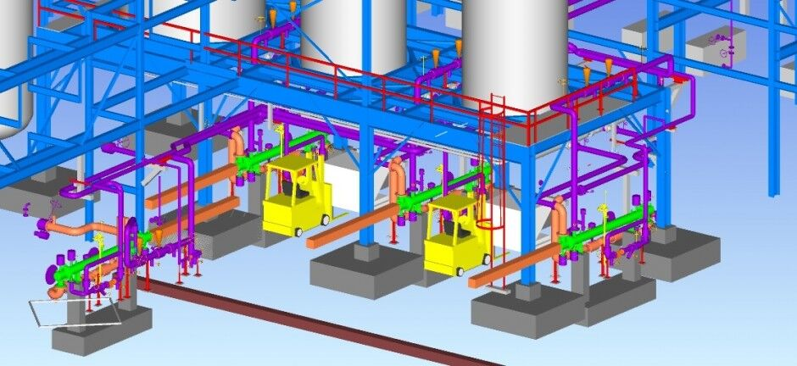

**How is 3D modelling useful for designing and infrastructure of the plant**

Dr Ghansyam trejani

Data Gathering: Gather all the necessary information about the factory, including architectural plans, blueprints, photographs, measurements, and any other relevant data. This information will serve as a reference for creating an accurate 3D representation.

Software Selection: Choose a 3D modelling software that suits your needs. There are various options available, such as Autodesk AutoCAD, SketchUp, Blender, or SolidWorks. Select a software that is compatible with the type of 3D model you want to create and that you are comfortable using.

Model Creation: a. Start by creating the basic structure of the factory. Use the architectural plans and measurements to accurately model the walls, floors, columns, and other structural elements. b. Add details to the model, such as doors, windows, staircases, and machinery. Incorporate specific elements that are unique to the factory, such as production lines, equipment, storage areas, and utilities. c. Pay attention to the scale, proportions, and accurate representation of the factory layout. Consider the spatial relationships between different sections and ensure that the model reflects the actual dimensions and functionality of the factory.

Texturing and Materials: Apply appropriate textures and materials to the 3D model to make it visually realistic. Use the software's texturing tools to assign different materials, colours, and finishes to the various surfaces, such as concrete, metal, glass, or wood. This step adds visual appeal and enhances the overall realism of the model.

Lighting and Rendering: Set up lighting within the 3D software to simulate realistic lighting conditions in the factory environment. This includes natural lighting, artificial lights, and shadows. Experiment with different lighting setups to achieve the desired atmosphere and visual effect. Once the lighting is set up, use the rendering capabilities of the software to generate high-quality images or even animations of the factory model.

Review and Refinement: Review the 3D model from different angles and perspectives to ensure accuracy and address any discrepancies or errors. Make necessary adjustments to the model's geometry, textures, lighting, or other elements to achieve the desired result. Iteratively refine the model until you are satisfied with its accuracy and visual representation.

Presentation and Collaboration: Once the 3D model is complete, it can be used for various purposes, such as presentations, visualizations, virtual tours, or collaborative design reviews. Export the model in a suitable format, such as OBJ, FBX, or STL, depending on the intended use.

**KEY TAKEWAYS –** although the intern was not able to understand much about the usage of 3D model in the manufacturing industry. But got to know that how much patience one need to have a precise measurement for every desired 3D model because it is a very measured process. One need to have a calm and composed mind for this.



**MASTARCARD**

By: Aarti Salvi (Head HR, Mastercard)

It was a very engaging session by mam Mrs. Aarti Salvi. It was session giving knowledge about the ‘elements of an effective talent acquisition strategy’ and the ways to develop the talent and etiquettes that are required in an individual’s personality for getting an appropriate placement in a reputed company.

In this session the activity called ‘wheel of life’ was performed by the students, in which they assessed themselves based on certain parameters of life such as:

* finance
* personal growth
* health
* family
* social life
* relationship
* attitude
* career etc.

on a scale of 10. This activity helped the students to know about where they stood in their current life and where they need to reach throughout the path of life. Then the students were taught about the talent acquisition strategy, with the help of which the students would extract the talent in the future for their companies.

Some of the points to remember for effective talent acquisition strategy are given as follows:

* work force planning
* company brand building
* sourcing and recruitment
* using new technologies
* comprehension onboarding
* use of data analytics etc.

**KEY TAKEWAYS –** she was a very interactive mentor; she gave all the basics idea of how to present yourself in front of the people. She gave all the necessary and needed information which is common for all the types of interviews whether it is for any industry or for any other profession. Her topic was the most general topic which is evergreen that rather then making any product first one need to get into that company, for that we should know the basic pillars of it.



**PRERNA BIO-INNOVATION AND RESEARCH PVT. LTD.**

-Deepak Barot (President and CEO)

It was an engaging session that taught the students important traits that will help them succeed as entrepreneurs in the future. knowledgeable insights regarding the startup's success, Shristi Innovations.

The session provided a comprehensive understanding of the mistakes that new entrepreneurs make and the repercussions that follow. Additionally, it taught the students how to avoid making the same mistakes again in later stages of their businesses.

It also taught us about some of the steps that must be taken or what is required to be a successful entrepreneur. The following are some points regarding the subject:

* individual should possess high risk-taking ability.
* he/she should be filled with self-confidence.
* he/she should develop unique or creative way of thinking from the rest of the world to develop a successful product.
* individual should possess high tolerance failures an should learn from the mistakes committed in past and should be able to strike back stronger in future.

**KEY TAKEWAYS –** he gave us the glimpse of the seeds of entrepreneurship, that why people become this to want a financial success, job security, and quality of life.

We got to know the basic characters of a good entrepreneurship is that one should have a vision, high energy level, self-confidence, tolerance of failure, need to achieve, creativity, tolerance for ambiguity, internal locus of control, inquisitive, responsible, risk taker, goal oriented. Information about the 5-step process which was discovery, concept development, resourcing, actualization, harvesting. One should have a business plan and to finance that business is a must.

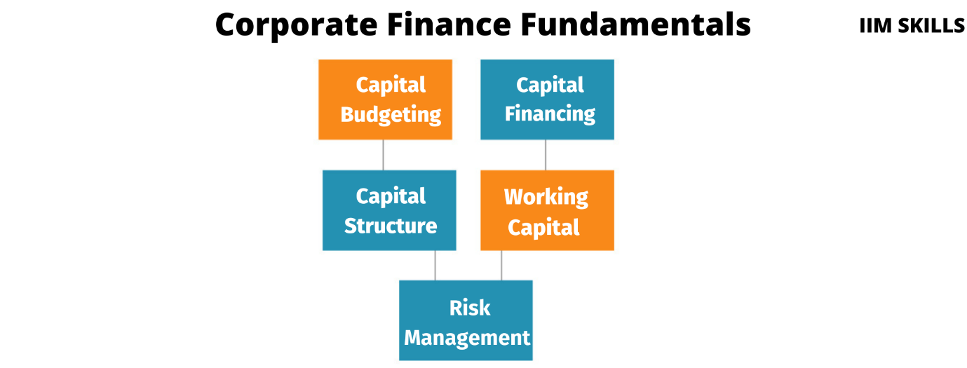

**ORGANISATION STRUCTURE AND CORPORATE**

**FINANCES**

By: CA Abbas Gulamhusenwala (Aims Associates)

Mr. Gulamhusenwala spoke about the organization's structure and corporate finances in his session. He provided us with well-informed insights regarding the formation of various businesses and the appropriate organizational structures they should adhere to for improved company performance.

Students learned about the advantages and disadvantages of the various business firm types that are available to them during this session.

These are some of the structures:

• Sole ownership

• Association

• LLP

• Confidential Ltd.

• Public Ltd.

• Joint Endeavors

• NGOs and so on.

The session covered the main aspects of corporate finances, including capital budgeting, capital structure, working capital management, profit retention, and so on.

It also provided us the knowledge about assets and liabilities of the company and also the knowledge for gathering and management of the capital for the business to occur.

Insights about the debt structures and the ways of borrowings were also provided by Mr. Abbas Gulamhusenwala.

The session helped us to acquire the knowledge about the term Market Cap and helped us to understand it in the best way possible.



**COMPLETE WORKING OF A PHARMA COMPANY**

-By: Paresh Dalal (Safety consultant, Alembic Pharma)

The aim, operating, manufacturing, and employee behavior toward the company were the topics of Mr. Dalal's session. He provided us with complete information about a company's manufacturing processes during this session. Additionally, how a company's work flow proceeds.

From an industrialist's point of view, the pharmaceutical industry's primary goal is to produce goods that meet society's fundamental requirements, operating independently on the global market and earning a healthy profit.

The work is divided up among the various departments, such as Project, Engineering and Management, Finance, Safety and Health, Quality Assurance and Quality Control, and Documentation, among others, in order to produce the required quantity and quality of products.

Here the students gained the ample of knowledge about the workflow that are designed and followed by the different companies according to their needs and requirements.

In this session the students were also provided with the knowledge about how the environment of a workplace should be so that the smooth workflow can take place without any disturbances.

It also helped us in knowing about how should be the behavior of an employ should be with the fellow mates as it would help them co- ordinate and increase the work efficiency.



**The Rolls Royce Company:**

: Dr Akash Bhavsar

Formation of Rolls-Royce Limited (1906): The company was founded on March 15, 1906, by Charles Rolls, a wealthy aristocrat, and Henry Royce, an engineer and manufacturer of electrical equipment. The partnership was formed to produce and sell high-quality automobiles.

The Silver Ghost (1907): Rolls-Royce gained early recognition and acclaim with the launch of the Silver Ghost, a luxurious car renowned for its exceptional build quality, performance, and reliability. The Silver Ghost established Rolls-Royce as the epitome of luxury and excellence in automobile manufacturing.

World War I and Aero Engine Production: During World War I, Rolls-Royce shifted its focus to aero engine production to support the war effort. Their engines, such as the Eagle and the Merlin, powered many Allied aircraft and played a significant role in the war.

Diversification into Aerospace (1940s-1950s): Following World War II, Rolls-Royce expanded its presence in the aerospace industry. The company developed jet engines like the Avon and the Conway, which powered various military and commercial aircraft.

Development of the RB211 Jet Engine (1960s-1970s): Rolls-Royce faced financial challenges during the development of the RB211 jet engine in the 1960s.

**What is the motto and vision of Rolls Royce?**

The motto of Rolls-Royce, the luxury automobile and engineering company, is "Strive for Perfection." This motto reflects the company's commitment to excellence, craftsmanship, and innovation in their products and services.

As for the vision of Rolls-Royce, it is centred around creating and maintaining a position as the world's leading luxury brand. The company aims to be renowned for its exceptional vehicles, renowned craftsmanship, and unparalleled customer experience. Rolls-Royce seeks to set industry standards and be a symbol of automotive and engineering excellence. Their vision also encompasses sustainability and environmental responsibility, focusing on creating a more sustainable future for luxury mobility.

**The 5 different company is and its performance :**



LINDE

**Introduction**:

Leading engineering, procurement, and construction (EPC) firm Linde Engineering India Pvt. Ltd. offers cutting-edge and environmentally friendly solutions to the oil and gas, petrochemical, chemical, and fertiliser industries. The business is a division of Germany's Linde Engineering, a world authority on EPC for industrial plants. With offices in Mumbai, Vadodara, Kolkata, and Chennai, Linde Engineering India has a significant presence in the country and has been providing services to the Indian market for more than 50 years.

Modern manufacturing facilities and a highly skilled team enable Linde Engineering India to provide its customers with EPC solutions of the highest caliber. Feasibility analyses, front-end engineering design, detailed engineering,

procurement, construction, commissioning, and maintenance are among the services offered by the business. Additionally, a variety of goods are provided by Linde Engineering India, such as air separation units, hydrogen plants, olefin plants, and natural gas processing plants.

The goal of Linde Engineering India is to meet the needs of its customers while having as little negative environmental impact as possible. The business has put in place several steps to lessen its carbon footprint, such as the use of renewable energy sources, energy-saving equipment, and waste reduction programs. As part of its commitment to promoting safety, Linde Engineering India has put in place a thorough safety program that includes training, audits, and regular safety reviews. Overall, Linde Engineering India provides its clients with high-quality, sustainable solutions and is a dependable partner for EPC solutions.

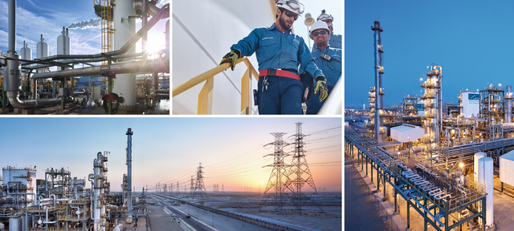

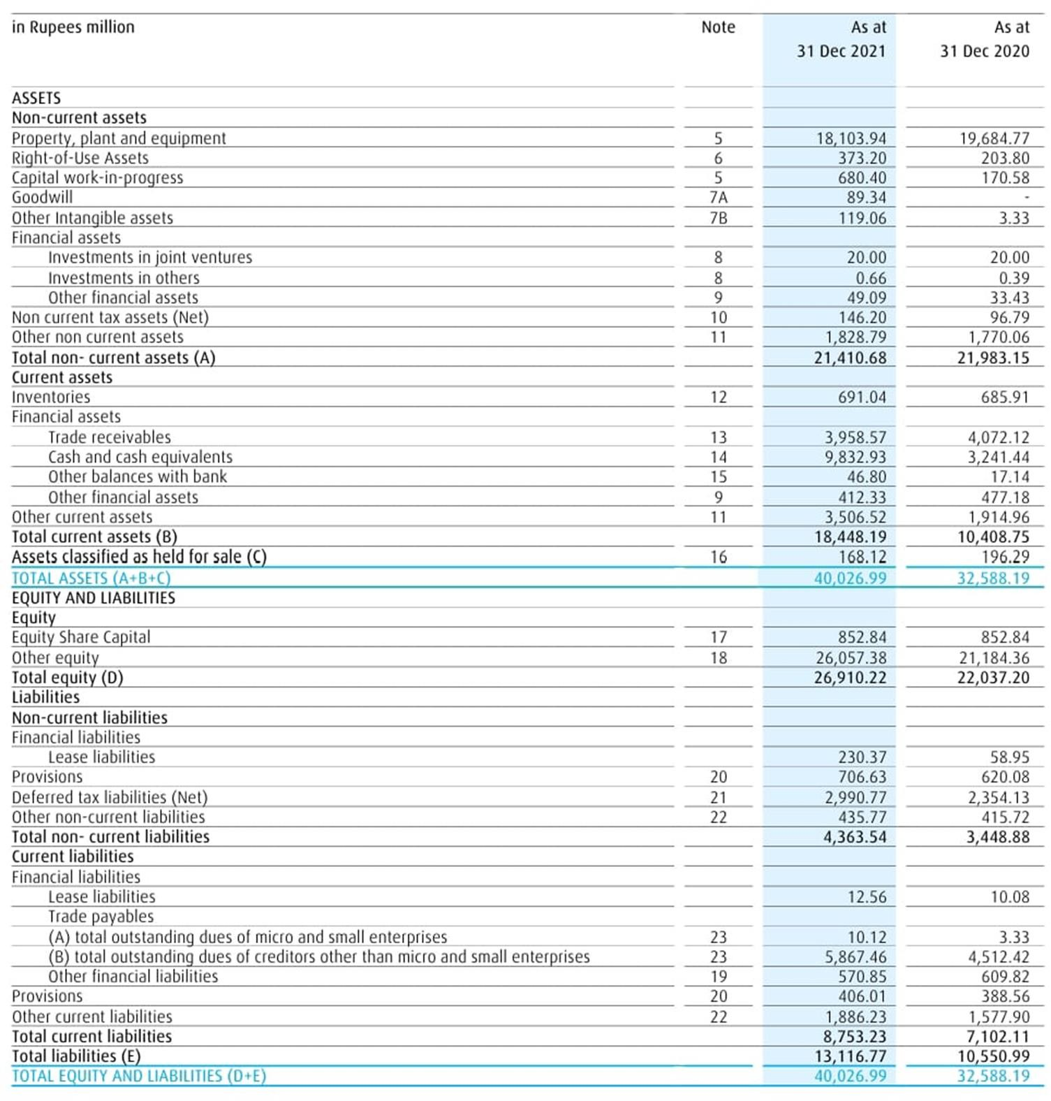

Balance Sheet of Linde till 31-Dec-2021

Linde Engineering uses a variety of methodologies to deliver high-quality engineering, procurement, and construction (EPC) solutions to its clients. Some of the key methodologies used by Linde Engineering include:

1. Project management: Linde Engineering has a proven project management methodology that is based on best practices and industry standards. The company's project managers are highly skilled and experienced in managing large-scale EPC projects and work closely with clients to ensure that projects are delivered on time and within budget.

Engineering design: Linde Engineering uses cutting-edge technology and software to design and optimize industrial plants. The company's engineers use a range of design methodologies, including process simulation, 3D modeling, and computational fluid dynamics (CFD), to ensure that plants are designed to the highest standards.

Procurement: Linde Engineering has a global network of suppliers and partners that enables it to procure high-quality materials and equipment at competitive prices. The company's procurement team uses a range of methodologies, including supplier evaluation and selection, to ensure that all materials and equipment meet the required specifications and quality standards.

Construction: Linde Engineering uses a range of construction methodologies, including modular construction and lean construction, to ensure that projects are delivered safely, efficiently, and to the highest standards.

Commissioning: Linde Engineering has a proven commissioning methodology that is based on industry standards and best practices. The company's commissioning team works closely with clients to ensure that all systems and equipment are fully operational and meet the required specifications.

**Conclusion:**

Linde Engineering India is a leading provider of EPC solutions in India, with a focus on safety, sustainability, and innovation. The company has established itself as a leader in the Indian EPC industry, thanks to its experienced team of engineers and project managers, as well as its commitment to delivering high-quality solutions to clients across various industries.

Linde Engineering India's focus on employee development and engagement, combined with its commitment to using advanced technologies and processes, makes it an attractive employer for professionals in the EPC industry. Looking to the future, Linde Engineering India is well- positioned to continue its growth and success, as the demand for sustainable and efficient industrial solutions continues to grow in India. Overall, Linde Engineering India is a company that is poised to play a key role in shaping the future of the Indian industrial landscape.



Aarti Industries Ltd. is a public limited company incorporated on 28 September 1984 with a corporate identification number (CIN) of L24110GJ1984PLC007301.

Headquartered at 71, Udyog Kshetra, 2nd Floor, Mulund-Goregaon Link Road, L B S Marg, Mulund(W), Mumbai-400080, Maharashtra, the company's registered office is located at Plot No.801, 801/23, GIDC Estate, Phase III, Vapi-396195, Gujarat.

Aarti Industries is listed on both, the Bombay Stock Exchange (BSE) as well as on the National Stock Exchange (NSE). The company was first traded on the BSE on 4 June 1992. On NSE, the company's shares were first traded on 29 December 1994.

Based on the distribution of the revenues earned by Aarti Industries, the company is classified into the Other chemical products industry. The main product/service of the company, which is the product/service from which it earns maximum revenue is Chemical & chemical products, nec.

Aarti Industries ranks 4th in the Other chemical products industry in terms of sales revenues in the year 2021-22.

Specialty Chemicals and Pharmaceuticals are the major revenue segments disclosed by the company as per its annual financial statements for the year 2021-22.

The company is an export-oriented company with foreign exchange earnings of the company comprising about 30.6 per cent of its sales.

Aarti Industries is a large-sized company with revenues of Rs.77,681.6 million as per the latest annual report of the company for the year ended 31 March 2022. It ranked 352nd in CMIE's rankings by size in 2021-22.

The company earned sales revenues of Rs.75,919.5 million for the year ended 31 March 2022 with a balance sheet size of Rs.95,117.5 million. It owns net fixed assets of Rs.43,361.6 million and the book value of its total assets is Rs.95,117.5 million.

Aarti Industries has been a profitable company for the past 31 years ended 31 March 2022. It was profitable at the operating level as well as the net level. It earned an operating profit of Rs.17,177 million and a net profit of Rs.12,882.6 million in 31 March 2022.

The company earned an operating margin of 22.6 per cent and a net margin of 16.6 per cent during the year ended 31 March 2022.

.

**Company’s Profile**

Aarti Industries Ltd., incorporated in 1984, supplies chemicals to global manufacturers of Dyes, Pigments, Agrochemicals, Pharmaceuticals & rubber chemicals. Aarti produces Benzene based basic and intermediate chemicals. The company has corporate office in Mumbai & representatives in U.S.A & Europe.

|  |  |
| --- | --- |
| **Points** | **Information** |
| Company Name | Aarti Industries Limited |
| Chairman/Managing Director | Shri Chandrakant Gogri Rajendra V.Gogri |
| Date of Establishment | 1984 |
| Establishment Place | Mumbai, Maharashtra |
| Revenue (in 2020) | INR 4,004 Crore |
| CEO | Rajendra V Gogri |
| Registered Address | Udyog Kshetra, 2nd Floor, Mulund Goregaon Link Road, Mulund (West), Mumbai-400080, Maharashtra, India |
| Telephone No. | 91 22 67976666/ 91 22 6797 6697/ 91 22 2591 8195 |
| Fax | 91 22 25653234/ 91 22 2565 3185 |
| Email | info@aarti-industries.com |
| Company Status | Active |
| Website | www.aarti-industries.com |

Aarti Industries Limited possesses a diverse portfolio of basic chemicals, agrochemicals, speciality chemicals and intermediates, which are extensively used in the manufacture of pharmaceuticals, Agri-products, polymers, additives, pigments, and dyes.

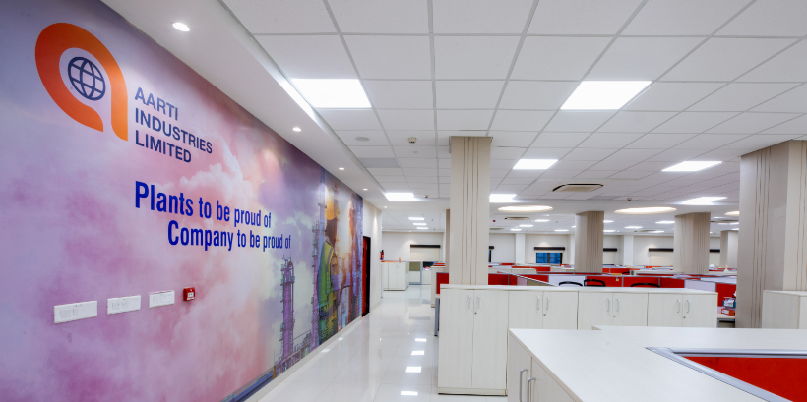

**Vision**

We Shall Become The First Choice Vendor Of Bulk Drugs And Achieve A Leadership Position By:

* Assuring consistent quality and timely delivery at competitive price.
* Providing customized solutions and service to meet changing requirements of customers.
* Choose the best and the most flexible manufacturing practices and methods.
* Adopt processes supported by proven technologies, which are cost effective and safe.
* Aim at customer orientation through continuous technology upgrade, high business ethics and new product development.

**Mission**

* Seek global market leadership
* Focus on growth and development of the product
* Continue to create winning culture, operating in highest standards of ethics and values with co-operation among competitor
* Strive for excellence in customer service, quality, and R&D

**Aarti Drugs Ltd. can be looked at as a reliable source of Generic Bulk Actives, Advanced Intermediates and Specialty Chemicals*.***



**R&D and Cost-Effective Process Development are customized per the customer’s needs.**



**Competitors and alternatives**



DCM Shriram

DCM Shriram is a business conglomerate operating through Agri-Rural, Chlor-Vinyl, and Value-Added segments.



**Bacil Pharma**

Logo for Laurus Labs

**Laurus Labs**

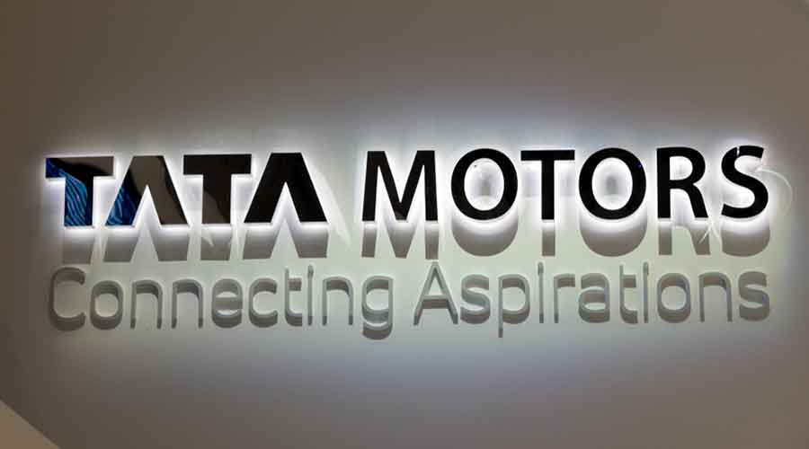

TATA MOTORS

**Introduction:**

Tata Motors, one of India's leading automakers, is a member of the renowned Tata Group, a conglomerate with a variety of business pursuits. With its corporate headquarters in Mumbai, Maharashtra, Tata Motors is a significant participant in both the local and international automotive industries.

Tata Motors was established in 1945 as Tata technical and Locomotive Co. Ltd., initially focusing on the production of locomotives and technical goods. However, it gradually expanded its product offerings to include electric cars, light trucks, and sedans. With a huge determination of vehicles in a few regions, Goodbye Engines has formed into a central part in the worldwide auto industry today.The business vehicle part of Goodbye Engines rules the Indian market and creates a extensive variety of trucks, transports, and military vehicles. The responsibility of the business to innovation and development. In terms of sales revenues for the years 2021 and 2022, Tata Motors is the most successful company in the commercial vehicle sector. According to the company's annual financial statements for the years 2020–21, the primary revenue segments that were disclosed by the company include passenger vehicles and commercial vehicles. According to the most recent annual report for the year ending March 31, 2022, Tata Motors is a large company with revenues of Rs. 803,768 million. In terms of size, CMIE ranked it 57th in 2021 and 2022. The organization procured deals incomes of Rs.571,612.6 million for the year finished 31 Walk 2022 with a monetary record size of Rs.682,175.1 million. It claims net fixed resources of Rs. 140,757.6 million, and its total assets have a book value of Rs. 676,114.8 million. For the two years that ended on March 31, 2022, Tata Motors was profitable on an operating level.

However, it was unable to increase operating profitability to net profitability over the past three years. It experienced an overal deficit of Rs.18,964.7 million of every 31 Walk 2022 and a total deficit of Rs.24,388.8 million in the former year. During the year that ended on March 31, 2022, the business had an operating margin of 2.8% and a net loss margin of 3.3%. With a debt-to-equity ratio of 1.217 times, Tata Motors is a low-leveraged business that has borrowed Rs. 235,290.7 million in total.

As Tata Motors consolidated FY 2021-2022

• There were 52,351 employees were working in it.

• Around 10 lakh 86 thousand vehicles were sold.

• They have more than 9,300 sales & service points till 2022.

Tata Motors Limited, a USD 37 billion organisation, is a leading global automobile

manufacturer with a portfolio that covers a wide range of cars, SUVs, buses, trucks, pickups

and defence vehicles.

**Vision of Tata Motors:**

By FY 2024, Tata Motors will become the most aspirational Indian auto brand, consistently winning, by:

• Delivering superior financial returns.

• Driving sustainable mobility solutions.

• Exceeding customer expectations.

• Creating a highly engaged work force.

**Tata is not only consisting of Tata Motors; they also have different companies as**:

• TCS (Tata Consultancy Service).

• Tata steel.

• Tata chemicals.

• Tata Power. And more.

**Tata also owns other car brands such as:**

• Jaguar

• Land Rover 12

**They also run programs such as:**

- Health Vidyacharan

- Education Kaushalya

- Employability or Skilling Vasundhara

- Environment Amrutdhara

- Drinking Water Aadhaar

Besides the ongoing programmes for societal and community betterment, their teams respond to issues on ‘need’ basis across the year as well. In 2020-21, they reached out to impact 1,36,800 lives through our Covid Response initiatives, which involved provision of essentials and food supplies, equipping the ground-zero heroes, and educating masses for containment and protection, involving spends of around Rs 3.34 crores.

**Conclusion and future scope:**

In conclusion, Tata Motors is a business with a promising future and a long history. The organization

has areas of strength for a to development and supportability, and is continually searching for ways

to work on its items and administrations. With many jobs accessible, from designing to

showcasing and deals, Goodbye Engines offers numerous amazing open doors for development and improvement.

Planning ahead, Goodbye Engines is strategically situated to proceed with its progress in the auto

industry. The company is working on the creation of new goods and services to meet the requirements of a changing world and has made significant investments in electric and autonomous vehicle technology. With a solid spotlight on consumer loyalty and a guarantee to quality,

Goodbye Engines is ready to stay an innovator in the business into the indefinite future.

If you are interested in working for Tata Motors, it's important to have a strong background in your field and to stay up-to-date with the latest trends and technologies. With a focus on collaboration and teamwork, Tata Motors offers a supportive environment where employees can learn from one another and work together to achieve common goals. Whether you are just starting out in your career or looking to take the next step, Tata Motors could be the perfect place for you to grow and thrive.

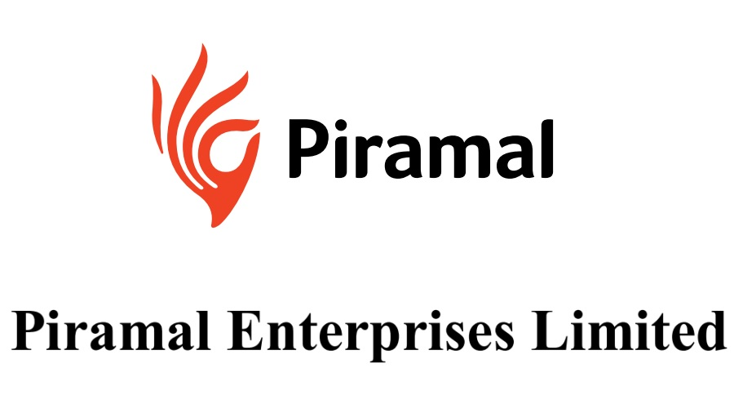

Piramal Industries Limited is a leading Indian multinational company that operates in various sectors, including pharmaceuticals, financial services, and healthcare analytics. The company was founded in 1984 by Ajay Piramal and has its headquarters in Mumbai, India.

The pharmaceutical business of Piramal Industries focuses on the development, manufacturing, and marketing of a wide range of healthcare products, including generic drugs, active pharmaceutical ingredients (APIs), and contract development and manufacturing services (CDMO). The company has a strong presence in both domestic and international markets and has partnerships with several global pharmaceutical companies.

In addition to its pharmaceutical business, Piramal Industries has also ventured into financial services. It provides a range of financial solutions, including corporate finance, real estate financing, and investment banking services. The company's financial services division operates through its subsidiary, Piramal Capital and Housing Finance Ltd.

Piramal Industries has made significant investments in healthcare analytics through its subsidiary, Decision Resources Group (DRG). DRG offers comprehensive research and analytics services to healthcare organizations, pharmaceutical companies, and medical technology companies, helping them make informed business decisions.

Over the years, Piramal Industries has achieved significant growth and has become one of India's leading diversified companies. The company has a strong commitment to innovation, quality, and customer satisfaction. It has received numerous awards and recognition for its contributions to the pharmaceutical and healthcare sectors.

**Company Profile**

Piramal Enterprises Limited has a reputation for integrity, transparency, and ethical business practices. The company is committed to creating long-term value for its stakeholders and contributing to the socio-economic development of the communities in which it operates.

Founded in 1984 by Ajay Piramal, PEL initially started as a textile business and later expanded its operations into other industries. Over the years, the company has transformed into a major player in the Indian business landscape, with a strong focus on innovation, entrepreneurship, and sustainable growth.

Here is an overview of the key business divisions and operations of Piramal Enterprises Limited:

**Pharmaceuticals**: PEL's pharmaceutical division focuses on developing and manufacturing a wide range of generic and specialty pharmaceutical products. The company has a presence in therapeutic areas such as pain management, respiratory, and critical care. It also has a robust contract manufacturing business, providing services to global pharmaceutical companies.

**Healthcare Insights & Analytics**: PEL's healthcare information management division offers insights, analytics, and data solutions to healthcare providers, payers, and other stakeholders in the healthcare industry. This division leverages advanced technologies and data analytics to improve healthcare outcomes, patient safety, and operational efficiency.

**Financial Services**: PEL operates in the financial services sector through its subsidiaries, including Piramal Capital and Housing Finance Limited (PCHFL) and Piramal Fund Management. PCHFL provides a wide range of financial services, including real estate financing, corporate lending, and infrastructure financing. Piramal Fund Management is involved in real estate private equity and structured debt investments.

**Real Estate**: PEL has a strong presence in the Indian real estate market through its subsidiary, Piramal Realty. The company focuses on developing premium residential and commercial projects in strategic locations across major cities in India. Piramal Realty emphasizes sustainability and quality in its real estate developments**.**

**Equity and Ownership.**

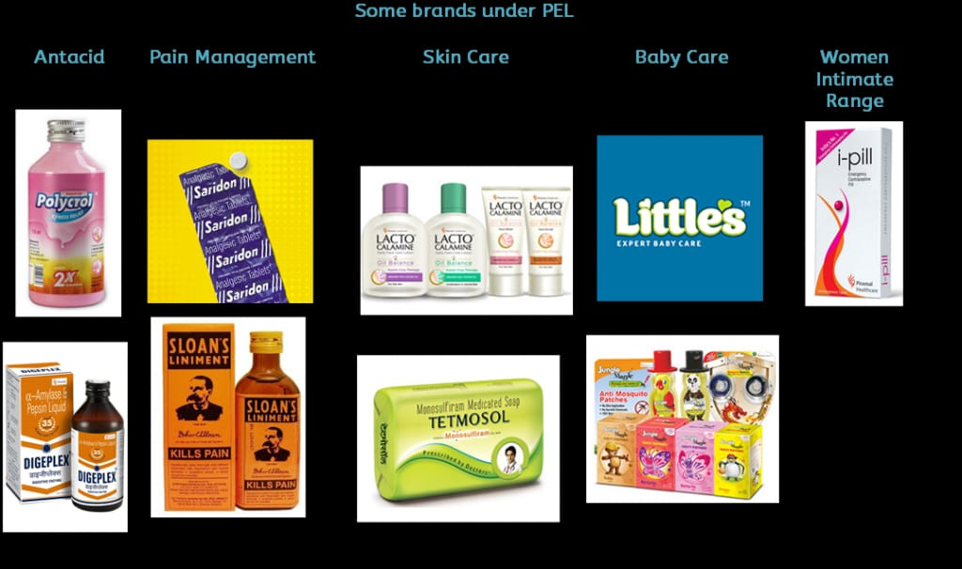

**Vision, Mission and Strategy**

**Vision**:

A company's vision statement outlines its long-term aspirations and the impact it aims to achieve. It expresses the organization's goal and provides direction for its activities. Unfortunately, I do not have the specific vision statement of Piramal Enterprise Limited. However, a typical vision statement may focus on growth, innovation, market leadership, or creating value for stakeholders.

Mission: A company's mission statement outlines its core purpose and defines the primary objectives it seeks to accomplish. It encapsulates the organization's reason for existence and guides its decision-making process. While I do not have access to Piramal Enterprise Limited's mission statement, a typical mission statement may emphasize providing quality products or services, addressing customer needs, fostering a positive work environment, or contributing to the community.

**Strategies:**

Corporate strategies encompass the overall approach a company adopts to achieve its mission and vision. These strategies typically involve multiple elements, such as market positioning, growth initiatives, risk management, and resource allocation. Without specific information on Piramal Enterprise Limited's strategies, it is challenging to provide precise details on their approach. However, companies often employ strategies such as diversification, innovation, partnerships, acquisitions, geographic expansion, or focusing on core competencies to achieve their goals.

To gain accurate and up-to-date information about Piramal Enterprise Limited's vision, mission, and strategies, I recommend visiting the company's official website or reviewing their latest corporate reports and announcements.

**Competitors and Alternatives**

Competitors in the Pharmaceuticals sector:

Sun Pharmaceutical Industries Ltd.

Lupin Limited

Dr. Reddy's Laboratories Ltd.

Cipla Limited

Cadila Healthcare Limited

Competitors in the Financial Services sector:

Bajaj Finserv Limited

Housing Development Finance Corporation Limited (HDFC)

ICICI Bank Limited

Axis Bank Limited

Kotak Mahindra Bank Limited

Competitors in the Information Management sector:

Tata Consultancy Services Limited (TCS)

Infosys Limited

Wipro Limited

HCL Technologies Limited

Tech Mahindra Limited

Alternatives to Primal Enterprises Limited in specific business segments could include:

Pharmaceuticals:

Eurobond Pharma Limited

Torrent Pharmaceuticals Limited

Glen mark Pharmaceuticals Limited

Akeem Laboratories Limited

Diva’s Laboratories Limited

Financial Services:

Edelweiss Financial Services Limited

Reliance Capital Limited

L&T Finance Holdings Limited

Mahindra & Mahindra Financial Services Limited

India bulls Housing Finance Limited

Information Management:

WNS (Holdings) Limited

First source Solutions Limited

Enact Limited

EXL Service Holdings, Inc.

Wipro Limited (Wipro HOLMES)

**Strengths:**

Diversified business portfolio: Piramal Enterprise Limited operates in various sectors, including pharmaceuticals, financial services, and healthcare analytics. This diversification provides stability and potential for growth.

Strong presence in the Indian market: The company has a long-standing presence in the Indian market and has established itself as a reputable and trusted brand.

Focus on innovation: Piramal Enterprise Limited emphasizes innovation in its products and services, which enables it to stay competitive and adapt to changing market dynamics.

Strong financial position: The company has a strong financial foundation, which enables it to invest in new ventures and pursue growth opportunities.

Experienced leadership: Piramal Enterprise Limited benefits from experienced and capable leadership, which drives strategic decision-making and long-term growth.

**Weaknesses:**

Vulnerability to regulatory changes: The pharmaceutical and healthcare industries are subject to strict regulations, and any changes in regulations can impact Piramal Enterprise Limited's operations and profitability.

Exposure to economic cycles: The company's financial services business is susceptible to economic fluctuations, and downturns can negatively affect its profitability.

Limited global presence: While Piramal Enterprise Limited has a strong presence in the Indian market, its global footprint is relatively limited. This lack of global diversification may limit its growth potential.

**Opportunities:**

Growing pharmaceutical market: The pharmaceutical industry in India and globally is experiencing growth, driven by factors such as an aging population and increased healthcare spending. Piramal Enterprise Limited can capitalize on this trend by expanding its pharmaceutical business.

Expansion into emerging markets: There are significant opportunities for Piramal Enterprise Limited to expand its presence in emerging markets, where there is growing demand for pharmaceuticals and healthcare services.

Strategic partnerships and acquisitions: The company can pursue strategic partnerships or acquisitions to enhance its capabilities, enter new markets, or expand its product offerings.

Technological advancements: Advancements in healthcare technology and analytics provide opportunities for Piramal Enterprise Limited to develop innovative solutions and improve its healthcare analytics business.

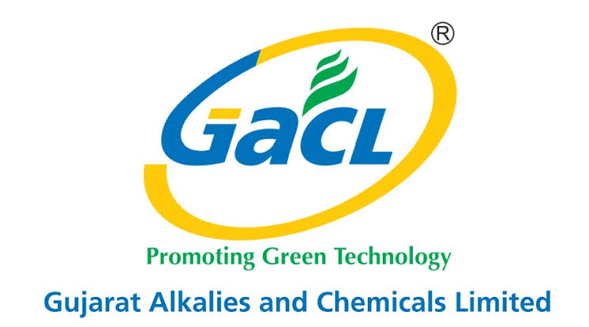

**GACL( GUJARAT ALKALIES AND CHEMICALS LIMITED)**

Gujarat Alkalies and Chemicals Limited (GACL) is a company based in Gujarat, India. It was established in 1973 as a joint sector company between the Government of Gujarat and Gujarat Industrial Investment Corporation (GIIC). GACL is involved in the manufacturing and marketing of a wide range of chemicals, including caustic soda, chlorine, hydrochloric acid, stable bleaching powder, hydrogen peroxide, and various other chemical intermediates.

The company has its manufacturing facilities located in Vadodara, Dahej, and Nandesari in Gujarat. GACL's products find applications in diverse industries such as textiles, paper, dyes, pharmaceuticals, fertilizers, petrochemicals, and water treatment, among others.

GACL has achieved significant growth over the years and has been recognized for its excellence in manufacturing, safety, and environmental practices. The company has received various awards and certifications for its commitment to quality, including ISO 9001, ISO 14001, and OHSAS 18001 certifications.

In addition to its chemical manufacturing operations, GACL is also involved in the development of infrastructure projects and renewable energy generation. The company has set up wind power projects in Gujarat and Rajasthan to harness clean and sustainable energy sources.

Gujarat Alkalies and Chemicals Limited is known for its focus on sustainable and responsible business practices. It strives to minimize its environmental impact, promote employee welfare, and contribute to the overall well-being of society.

**Company’s Profile**

Gujarat Alkalies and Chemicals Limited (GACL) is a company based in Gujarat, India. It is a leading manufacturer of chemicals such as caustic soda, chlorine, hydrochloric acid, hydrogen peroxide, and various other chemicals. GACL was established in 1973 as a subsidiary of Gujarat Industrial Investment Corporation (GIIC) with the objective of developing the industrial sector in Gujarat.

The company operates multiple manufacturing facilities in Gujarat, including the Vadodara complex, Dahej complex, and the Nandesari complex. These complexes are equipped with state-of-the-art technology and infrastructure to produce a wide range of chemicals. GACL's products find applications in industries like textiles, paper, detergent, water treatment, pharmaceuticals, agriculture, and many others.

Gujarat Alkalies and Chemicals Limited is known for its commitment to sustainable development and environmental protection. The company has implemented various eco-friendly practices, including the use of energy-efficient processes, waste management systems, and renewable energy sources.

Apart from chemical manufacturing, GACL is also involved in power generation. The company operates a 60.5 MW wind farm located at Nakhatrana, Kutch district, in Gujarat.

As of my knowledge cutoff in September 2021, GACL has been consistently expanding its operations and diversifying its product portfolio. However, for the most up-to-date and accurate information about Gujarat Alkalies and Chemicals Limited, I recommend referring to their official website or contacting them directly

**Equity and Ownership**

|  |  |  |  |  |  |  |
| --- | --- | --- | --- | --- | --- | --- |
| **Gujarat Alkalies & Chemicals Ltd.** | | | | | | |
| Ownership of Equity Shares & Number of Owners : 31 Mar 2023 | | | | | | |
|  | **Shares Held** | | **Demat shares** | **Holders** | **Pledged shares** | |
|  | (Nos.) | (% of Total) | (Nos.) | (Nos.) | (Nos.) | (% of Holding) |
| **Total** | 73,436,928 | 100 | 72,685,614 | 84,097 |  |  |
| **Promoters** | 33,986,310 | 46.28 | 33,986,310 | 7 |  |  |
| Indian | 33,986,310 | 46.28 | 33,986,310 | 7 |  |  |
| Individuals & HUF |  |  |  |  |  |  |
| Central & State Govt. | 21 |  | 21 | 1 |  |  |
| Corporate Bodies | 33,986,289 | 46.28 | 33,986,289 | 6 |  |  |
| FIs & Banks |  |  |  |  |  |  |
| Others |  | 0 |  |  |  |  |
| Foreign |  |  |  |  |  |  |
| Individuals(NRIs) |  |  |  |  |  |  |
| Corporate Bodies |  |  |  |  |  |  |
| Institutions |  |  |  |  |  |  |
| Qualified Foreign Investor |  |  |  |  |  |  |
| Others |  |  |  |  |  |  |
| Persons acting in concert |  |  |  |  |  |  |
| **Non-promoters** | 39,450,618 | 53.72 | 38,699,304 | 84,090 |  |  |
| Institutions | 2,626,709 | 3.58 | 2,625,634 | 89 |  |  |
| Mutual Funds/UTI | 100,577 | 0.14 | 100,221 | 10 |  |  |
| Banks, FIs,Insurance Cos. | 945,653 | 1.29 | 945,068 | 10 |  |  |
| Insurance Companies | 944,062 | 1.29 | 944,012 | 2 |  |  |
| Financial Institutions & Banks | 1,591 |  | 1,056 | 8 |  |  |
| Central & State Government |  |  |  |  |  |  |
| FIIs | 1,520,211 | 2.07 | 1,520,211 | 62 |  |  |
| Venture Capital Funds |  |  |  |  |  |  |
| Foreign Venture Capital |  |  |  |  |  |  |
| Qualified Foreign Investor |  |  |  |  |  |  |
| Others | 60,268 | 0.08 | 60,134 | 7 |  |  |
| Non-institutions | 36,823,909 | 50.14 | 36,073,670 | 84,001 |  |  |
| Corporate Bodies | 21,950,746 | 29.89 | 21,947,595 | 358 |  |  |
| Individuals | 13,516,248 | 18.4 | 12,829,938 | 80,813 |  |  |
| Nominal invest. upto Rs. 1 lakh |  |  |  |  |  |  |
| Nominal invest. over Rs. 1 lakh |  |  |  |  |  |  |
| Qualified Foreign Investor |  |  |  |  |  |  |
| Others | 1,356,915 | 1.84 | 1,296,137 | 2,830 |  |  |
| **Shares held by Custodians** |  |  |  |  |  |  |
| Promoters |  |  |  |  |  |  |
| Non-promoters |  |  |  |  |  |  |

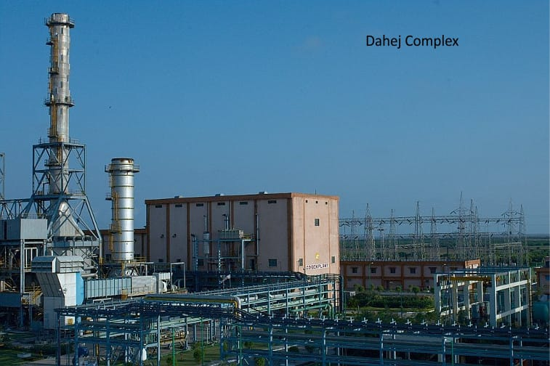

**Vision, Mission, and Strategies**

Gujarat Alkalies and Chemicals Limited (GACL) is a major chemical manufacturing company based in Gujarat, India. While I don't have access to the specific vision, mission, and strategies of GACL after my September 2021 knowledge cutoff, I can provide you with a general framework of what these elements typically entail for a company like GACL.

Vision Statement:

A vision statement outlines the long-term aspirations and goals of an organization. It represents the desired future state that the company aims to achieve. Although I don't have the exact vision statement of GACL, it may focus on their ambitions for growth, innovation, sustainability, market leadership, and creating value for stakeholders.

Mission Statement:

A mission statement describes the purpose and core activities of the organization. It outlines the company's primary objectives and how it aims to serve its customers, employees, and other stakeholders. GACL's mission statement may include elements such as manufacturing and supplying high-quality chemicals, contributing to the development of the chemical industry, and promoting sustainable practices.

Strategies:

Strategies are the broad approaches and plans that a company employs to achieve its vision and mission. These strategies may vary based on the industry, competitive landscape, and specific goals of the organization. Here are some possible strategies that GACL could consider:

Market Expansion:

GACL could focus on expanding its presence in existing markets or explore new markets domestically and internationally. This could involve developing new products, entering into strategic partnerships, and leveraging its manufacturing capabilities.

Product Diversification: GACL may aim to diversify its product portfolio by introducing new chemical products or expanding into related industries. This strategy can help mitigate risks associated with dependency on specific products and provide new revenue streams.

Operational Excellence:

GACL might prioritize operational efficiency and continuous improvement initiatives. This includes optimizing manufacturing processes, implementing cost-saving measures, enhancing supply chain management, and adopting new technologies to improve productivity.

Sustainability and Environmental Responsibility:

Given the growing importance of sustainable practices, GACL may adopt strategies to minimize its environmental footprint. This could involve investing in cleaner production technologies, waste management systems, and renewable energy sources, as well as promoting responsible resource consumption and reducing greenhouse gas emissions.

Research and Innovation:

GACL could emphasize research and development activities to drive innovation, develop new products, improve existing ones, and stay ahead of market trends. This strategy may involve collaboration with research institutions, universities, and industry partners to foster technological advancements.

It is important to note that the actual vision, mission, and strategies of GACL may differ from the general framework outlined here. For accurate and up-to-date information, I recommend referring to GACL's official website, annual reports, or corporate communications.

**Competitor and Alternatives**

Gujarat Alkalies and Chemicals Limited (GACL) is a chemical manufacturing company based in Gujarat, India. While there are several competitors and alternatives in the chemical industry, I can provide you with some notable ones in the context of GACL.

Tata Chemicals: Tata Chemicals is one of the major competitors of GACL. It is a global company with a diverse range of chemical products, including soda ash, salt, and specialty chemicals.

National Chemical and Fertilizers (NCF): NCF is another significant competitor of GACL. It is a government-owned company in India that produces a wide range of chemicals, fertilizers, and industrial products.

Gujarat Narmada Valley Fertilizers & Chemicals Ltd (GNFC): GNFC is a leading chemical company based in Gujarat. It manufactures and markets fertilizers, industrial chemicals, and petrochemicals. It competes with GACL in various chemical segments.

SRF Limited: SRF Limited is a diversified company that operates in different sectors, including chemicals and polymers. It produces a range of industrial chemicals, specialty chemicals, and packaging films. Although not solely focused on chemicals, it can be considered a competitor in certain product categories.

Deepak Nitrite Limited: Deepak Nitrite Limited is a chemical manufacturing company with a diverse product portfolio, including basic chemicals, fine and specialty chemicals, and performance products. It competes with GACL in certain chemical segments.

These are just a few examples of competitors in the chemical industry. The market for chemicals is vast, and there are numerous other companies that may compete with GACL in specific product categories or regions. It's essential to conduct thorough market research to get a comprehensive understanding of the competitive landscape.

**Strengths:**

Established Presence: GACL has a strong presence in the chemicals industry and is one of the leading manufacturers of caustic soda, chlorine, and other chemicals in India.

Diversified Product Portfolio: The company offers a wide range of products across various segments, including industrial chemicals, chlorochemicals, and fluor specialties, which helps in mitigating risks and capturing opportunities in different markets.

Technological Expertise: GACL has developed expertise in the production and utilization of advanced technologies, enabling it to maintain a competitive edge in the industry.

Strong Distribution Network: The company has an extensive distribution network that allows it to reach customers across different regions, both domestically and internationally.

Synergy with Gujarat State Fertilizers & Chemicals Limited (GSFC): GACL benefits from its affiliation with GSFC, which provides access to shared resources, technical expertise, and operational synergies.

**Weaknesses:**

Dependency on Raw Materials: GACL relies on the availability and cost of raw materials, such as salt and natural gas, which can be subject to price volatility and supply disruptions, impacting the company's profitability.

Environmental Concerns: As a chemical manufacturer, GACL faces challenges in managing and mitigating environmental impacts associated with it

operations. Compliance with environmental regulations is crucial to maintain public trust and avoid penalties.

Exposure to Market Fluctuations: GACL's financial performance is influenced by market dynamics, including changes in demand, prices, and competition. This exposure can affect the company's revenue and profitability.

**Opportunities:**

Growing Chemicals Industry: The increasing demand for chemicals in various sectors, including agriculture, pharmaceuticals, and water treatment, presents an opportunity for GACL to expand its market share and generate additional revenue.

Infrastructure Development: The Indian government's focus on infrastructure development, such as smart cities and industrial corridors, creates a potential market for GACL's products, especially in areas like construction chemicals and water treatment.

Renewable Energy Initiatives: The shift towards renewable energy sources provides opportunities for GACL to diversify its product offerings and explore the production of chemicals used in renewable energy technologies, such as solar panels and energy storage.